A000-Afr-Ghana-Millefiori Pearls-19th c

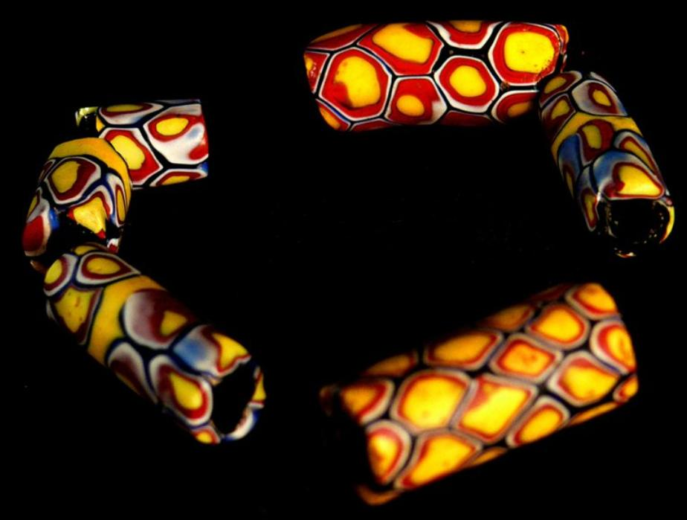

Afr-Ghana-Millefiori Pearls-19th

Ghana, Millefiori Pearls, 0.5  inches, 0.01 pounds, glass.

Case No.: 6

**Accession No.**

**Formal Label:** Afr-Ghana-Millefiori Pearls-19th

**Display Description:**

The trans-Saharan trade and exchange routes were an important aspect of Ghanaian trade beginning in the prehistoric period. It was through these networks that gold was exchanged and Islam entered into West Africa. Several terra cotta busts and heads of prominent people engaged in this trade document the presence of many non-Africans in Ghana beginning in the early Common Era. The Millefiori Pearls are another substantiation of this trade that came originally from Mediterranean seaports. These “pearls” exemplify the ancient Phoenician expertise in glass blowing that managed to survive on the Mediterranean seacoast. With the advent of the trans Saharan trade beginning with the expansion of Islam in 700 CE glass beads became an object of trade and adornment as well as being important status symbols. The European entrada in 1482 beginning with the Portuguese and continuing with the Bavarians, Danish and English, introduced European glass beads into the trade and exchange of these prized objects. However, the indigenous manufacture of beads continued throughout all of the foreign bead exchanges, shifting with new methods of manufacture and production. Today the Tamale students of the Cultural Center produce their own beads in accordance with the ancient practices handed down by the indigenous bead manufacturers.

**LC Classification:**

**Date or Time Horizon:**

**Geographical Area:**

**Map:**

**GPS coordinates:**

**Cultural Affiliation:**

**Media:**

**Dimensions:**

**Weight:**

**Condition:**

**Provenance:**

**Discussion:**

References

*Aquandah, J. 1982. Rediscovering Ghana’s past. Harow, UK: Longman.

Stone beads from LSA sites on Kwahu escarpment, 300-2000 BC (p.29), quartx, porphyry, shell, bone beads, agricultural sites 2000-500 BC (p. 72).

*Aquandah, J. 1993. The Kintampo Complex: a case study of early sedentism and food production in Sub Sahelian West Africa. In: Archaeology of Africa, edited by T. Shaw, P. Sinclasir, B. Andah, and A. Okpoko, pp. 255-260. London: One World Archaeology, Routledge, Kegan, Paul.

Granite beads from agricultural complex at Boyase Hill, near Kumasi, Kintampo Complex

*Cardinall, A. W. 1924. Aggrey Beads of the Gold Coast. Journal of African Sociology 7:117-141.

De Corse, C. R. 2001. An archaeology of Elmina – Africans and Europeans on the Gold Coast, 1400-1900. Washington, D.C.: Smithsonian Press.

*De Corse, C. R. 1989. Beads as chronological indicators in West African archaeology – a re-examination. Beads—Journal of the Society of Bead Researchers (Ottawa) 1:41-53.

*Jeffreys, M. D. W. 1961. Aggrey beads. African Studies 20(2):97-114.

Posnansky, M. 1979. Archaeological aspects of the Brong-Ahafo region. In: Brong-Kyempin: Essays on the society, history and politics of the Brong people, edited by K Arhin, pp. 22-35. Accra: Afram Publications.

Ground striped glass and black furnace wound beads from Fustat, Old Cairo, via trans Sahara trade network, 1350-1450 AD.

Shinnie, P.L> and F.J. Kense 1989. Archaeology of Gonja – Excavations at Daboya. Calgary, Calgary University Press.

Seven milky quartz beads dating to 2000-1000 BC; stone and shell beads dating 2000 BC – 1800 AD; 63 imported glass beads (monochrome, multicolored, spherical, barrel, elongated from trans Sahara trade network, 700-1800 AD.

Wilson, Alexandra. 2003. The bead is constant. Ghana Universities Press for the Museum of Archaeology, University of Ghana.

**LC Classification:**

**Date or Time Horizon:**

**Geographical Area:**

**Map:**

**GPS coordinates:**

**Cultural Affiliation:**

**Media:**

**Dimensions:**

**Weight:**

**Condition:**

**Provenance:**

**Discussion:**

**References:**

